MÜHENDİSLİK FAKÜLTESİ
BİTİRME PROJESİ RAPOR DÜZENİ

- Kullanılacak Kağıt ve Çoğaltma
Bitirme projesi raporu A4 beyaz kağıdın sadece bir yüzüne yazılır. Çoğaltma fotokopi ile beyaz kağıda yapılır.

- Bitirme Projesinin Yazım Şekli
Bitirme Projesinin metni Times New Roman yazı karakteri ve 12 punto ile yazılır. Nokta ve virgülden sonra bir karakter boşluk bırakılır.

- Sayfa Düzeni
A4 boyutundaki kağıdın solundan 4,0 cm, sağından 2,0 cm, üstünden 3,0 cm ve altından 2,5 cm boşluk bırakılır. Şekil açıklamaları şeklin altına, tablo açıklamaları tablonun üstüne yazılır. Şekil ve tablo numaraları bölüm içindeki sıra ile numaralandırılır.

- Satır Aralıkları
Metin, 1 satır aralığı ile yazılır ancak paragraflar arasında 2 satır aralığı boşluk bırakılır.

- Başlıklar
Bölüm başlıkları (Önsöz, İçindekiler, Özet, Giriş, Ekler, Özgeçmiş) 1. derece başlıklar olarak yazılır.

Tüm başlıklar sola dayalı olarak yazılır ve uygun şekilde numaralandırılır. Başlıkların yazı karakterleri aşağıdaki gibi olmalıdır:

1. Derece başlıklar; BÜYÜK HARF; 12 PUNTO, KOYU
2. Derece başlıklar; Kelime Baş Harfleri Büyük, 12 Punto, Koyu
3. Derece başlıklar; Kelime Baş Harfleri Büyük, 12 Punto, İtalik Harf

- Denklemler
Denklemler metin içinde altta ve üstte birer satır boşluk bırakılarak yazılır. Denklemler satır başından 1 cm içeride olacak şekilde yazılır. Denklem numaraları sayfanın sağına, bölüm içinde verilen sıra numarası ile yazılır (4.6, 5.1gibi).

- Sayfa Numaraları
Bitirme Projesinin dış ve iç kapağı ve tutanak sayfası dışındaki tüm sayfaları, sayfa numarası sayfanın üst ve ortasına gelecek şekilde numaralandırılır.
- Atıf
Metinde atıflar yazar adı ve yayın yılı şeklinde parantez içinde verilir. Örneğin; Özçep (2012) zeminlerle ilgili…

- Kaynakların Yazımı
Bitirme projesinde faydalanılan ve metin içinde atıfta bulunulan yayınlar ‘KAYNAKLAR’ da yazar soyadlarına göre alfabetik sırayla sıralanır. Yayının basıldığı dergi, kongre kitapçığı ve kitabın adı italik olarak yazılır.

Dergilerdeki makaleler için; yazar/yazarların soyadı, ad/adlarının baş harfleri, yayın yılı, makalenin adı, derginin adı, cilt no (veya bölüm no), sayfa numarası yazılır. Örneğin;

Langel, R. A. and Estes, R. H., 1982, Ageomagneticfieldspectrum, Geophys. R. Letters,Vol. 9, No. 4, p. 250-253.

SENIOR PROJECT
Your project name should be placed here, ALL letters should be upper case and delete this notification before print this document.

SAMPLE PROJECT NAME

Your name and surname should be placed here, FIRST letters should be italic & upper case and delete this notification before print this document.

Submitted by:
Name Surname

Your supervisor’s name and surname should be placed here, FIRST letters should be upper case and delete this notification before print this document.
Titles are;
Instructor
Dr.Faculty Member
Assoc.Prof.
Professor

Project Supervisor: Title Name Surname

Finishing term of your project should be placed here, FIRST letters should be upper case and delete this notification before print this document. Examples are;
Spring 2018
Fall 2019
Spring 2019

Faculty of Engineering
Antalya Bilim University
Spring 2018
FOREWORD
Margin from the left is 4 cm and delete this notification before print this document.

Students need an introductory course in computer science that exposes them to all of computer science. Computer science is not just about programming techniques. It rests on deep ideas and the nature of computation. We want students to understand these deep ideas, as well as grasp the practicality of computation and experience the pleasure of computing.
One line space between paragraphs and delete this notification before print this document.

We wrote The Schematics of Computation for one reason---we wanted a book that presents the fundamental ideas of computer science in a way that students can understand. Introductory books in other fields such as physics introduce the areas of the field (mechanics, electricity and magnetism, and optics), while introductory computer science books often have chapters on how to use two-dimensional arrays.

We resolved to write a book that not only gives students essential programming skills, but also provides a vision of what computer science is about. We want to reach those individuals who are already committed to computer science, as well as those who plan to take computer science courses as part of a general education. We hope our enthusiasm for the field will encourage students to pursue advanced studies in computer science.
Margin from the right is 2 cm and delete this notification before print this document.

Margin from the bottom is 2.5 cm and delete this notification before print this document.

This is the last line of this page.
TABLE OF CONTENTS

ABSTRACT ……………………………………………………………………... | 3
1 INTRODUCTION …………………………………………………………… | 4
2 DISTRACTED DRIVER DETECTION …………………………………...…. | 12
2.1 Dataset ……………………………………………………………...... | 12
2.1.1 Title of subsubsection ……………………………………………... | 13
2.1.2 Title of next subsubsection …………………………………….….. | 14
2.2 Title of Next Subsection ……………………………………………...... | 14
3 TITLE OF SECTION (THE INDENTATION EXAMPLE IN A LONG SECTION TITLE) ……………………………………………………………… | 15
3.1 Title of Another Subsection ………………………………………….… | 16
3.2 Title of Next Subsection ……………………………………………… | 18
4 CONCLUSIONS ……………………………………………………...……… | 20
REFERENCES ………………………………………………………………… | 26

ABSTRACT
Margin from the top is 3.0 cm and delete this notification before print this document.

Every year, many car accidents due to driver fatigue and distraction occur around the world and cause many casualties and injuries. Engineers and researchers in the automobile industry have tried to design and build safer automobiles, but traffic accidents are unavoidable. As Computer Engineers, if we deeply investigated the causes of these accidents, we will find that these behavioral and roadway accident patterns can be useful to develop traffic safety control policies.
Margin from the left is 4.0 cm and delete this notification before print this document.

One line space between paragraphs and delete this notification before print this document.

We believe that to obtain the greatest possible accident reduction effects with limited budgetary resources, it is important that measures be based on scientific and objective surveys of the causes of accidents and severity of injuries.

This paper is about how to address this problem by Internet of Things and machine learning, two technologies that are taking the world by storm and will someday become an inherent part of every aspect of our lives.
Margin from the right is 2.0 cm and delete this notification before print this document.

Margin from the bottom is 2.5 cm and delete this notification before print this document.

This is the last line of this page.
1 INTRODUCTION
1st degree headings should be ALL CAPS, bold, 12pts and font is Times New Roman, FIRST letters should be upper case and delete this notification before print this document.

The transportation industry is associated with high maintenance costs, disasters, accidents, injuries and loss of life. Hundreds of thousands of people across the world are losing their lives to car accidents and road disasters every year. According to the World Health Organization, there were 1.25 million road traffic deaths globally in 2013.

The related costs were estimated at $152 billion. And this doesn’t account for general maintenance and repairs costs of the road and highway systems, which earmark billions of dollars of public funds every year and are still underfunded.
2nd degree headings should be bold, 12pts and font is Times New Roman, FIRST letters should be upper case and delete this notification before print this document.
These statistics motivated us to work on developing a System that helps in reducing the amount of car accidents around the world, where There are several approaches that researchers have employed to study this problem. These include neural network and so on. Thus, detecting the driver's state is the beginning of our journey, where more than a quarter of all car crashes in America are likely caused by cell phone use.
Citations should be in this form; Author Surname and in paranthesis publication year.
Examples are; Özcep (2012), Langel (1982)
Delete this notification before print this document.
2 DISTRACTED DRIVER DETECTION

2.1 Dataset

The used dataset in our project was supplied by Langel (1982) and a challenge on the Kaggle platform, the name of the challenge is “State Farm Distracted Driver Detection”, the given Dataset is about driver images, each taken in a car with a driver doing something in the car (texting, eating, talking on the phone, makeup, reaching behind, etc).

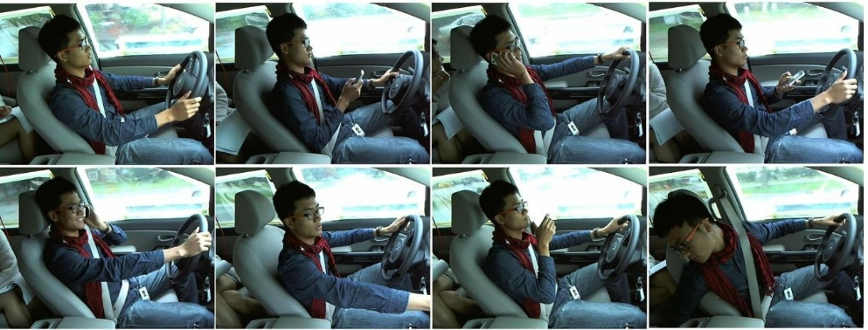
The dataset consists of 22400 training and 79727 testing images (640 × 480 full color) of people either driving safely or doing one of eight kinds of distracted behaviors.

3rd degree headings should be italic, 12pts and font is Times New Roman, Keyword initials should be upper case and delete this notification before print this document.

Figure 1 – A sample of Dataset

2.1.1 Sub Section

These statistics motivated us to work on developing a system that helps in reducing the amount of car accidents around the world, where There are several approaches that researchers have employed to study this problem. These include neural network and so on.

These statistics motivated us to work on developing a System that helps in reducing
Margin from the bottom is 2.5 cm and delete this notification before print this document.

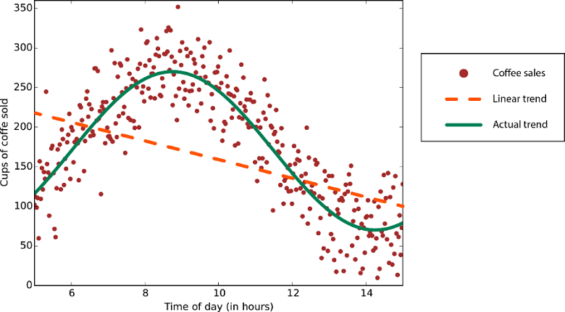
Figures should be centered and named below and Figure titles should be centered and named with numbers and delete this notification before print this document.
Figure 2 – A graph
Equations should be centered, Equation titles should be right-aligned and a blank line should be left before & after the equation and delete this notification before print this document.

C=12n∑x‖y(x)−aL(x)‖2
Equation 1 – Sum

Tables should be centered and named below and Table titles should be centered and named with numbers and delete this notification before print this document.
Model | F1-Score | Top-1 Accuracy | Top-2 Accuracy | Loss
VGG16 +  CrossValidation | 99% | 96.2226% | 98.8833% | 0.14280
InceptionV3 + CrossValidation | 99% | 95.4531% | 97.9350% | 0.20000
ResNet50 + CrossValidation | 98% | 96.6773% | 98.7186% | 0.12851
Xception + CrossValidation | 98% | 94.1785% | 96.8790% | 0.30539
ResNet50 + VGG16 | 99% | 96,4499% | 98,8008% | 0.13565
VGG16 +  inceptionV3+Res Net50+Xception | 99% | 96.3080% | 98.1039% | 0.23126
Figures should be centered and named below and Figure titles should be centered and named with numbers and delete this notification before print this document.
Table 1 – Results
REFERENCES
References should be listed in alphabetical order and be written in this order; author’s surname, initials of name/names, publication
year, the name of the article, the name of the article, the volume number (or chapter no), the page number.
Delete this notification before print this document.
Angel, R. A. and Estes, R. H.,1982, Ageomagneticfieldspectrum, Geophys. R. Letters,Vol. 9,No. 4, p. 250-253.

Langel, R. A. and Estes, R. H.,1982, Ageomagneticfieldspectrum, Geophys. R. Letters,Vol. 9,No. 4, p. 250-253.

