Ali YETER

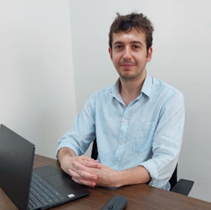

Research Assistant
Antalya Bilim University
Tourism Faculty

ali.yeter@antalya.edu.tr
Office no: B2-52

Education

- Bachelor Akdeniz University – Gastronomy and Culinary Arts (2016-2020)
- Master Akdeniz University – Gastronomy and Culinary Arts (2020- )

Academic Employment

- Research Assistant, Antalya Bilim University, Tourism Faculty (2022- )

Professional Employment

- Trendy Lara /Antalya / 2020 / Demi Chef
- Regnum Carya Belek / Antalya / 2019 / Cook
- Titanic Deluxe Golf Belek / Antalya / 2018 / Cook
- Silence Beach Hotel / Antalya / 2017 / Training

Research Interests
- Gastronomy and Tourism, Local Foods, Destination Food Image, Food and Beverage Cost Management

Languages
- Turkish Native
- English Fluent

