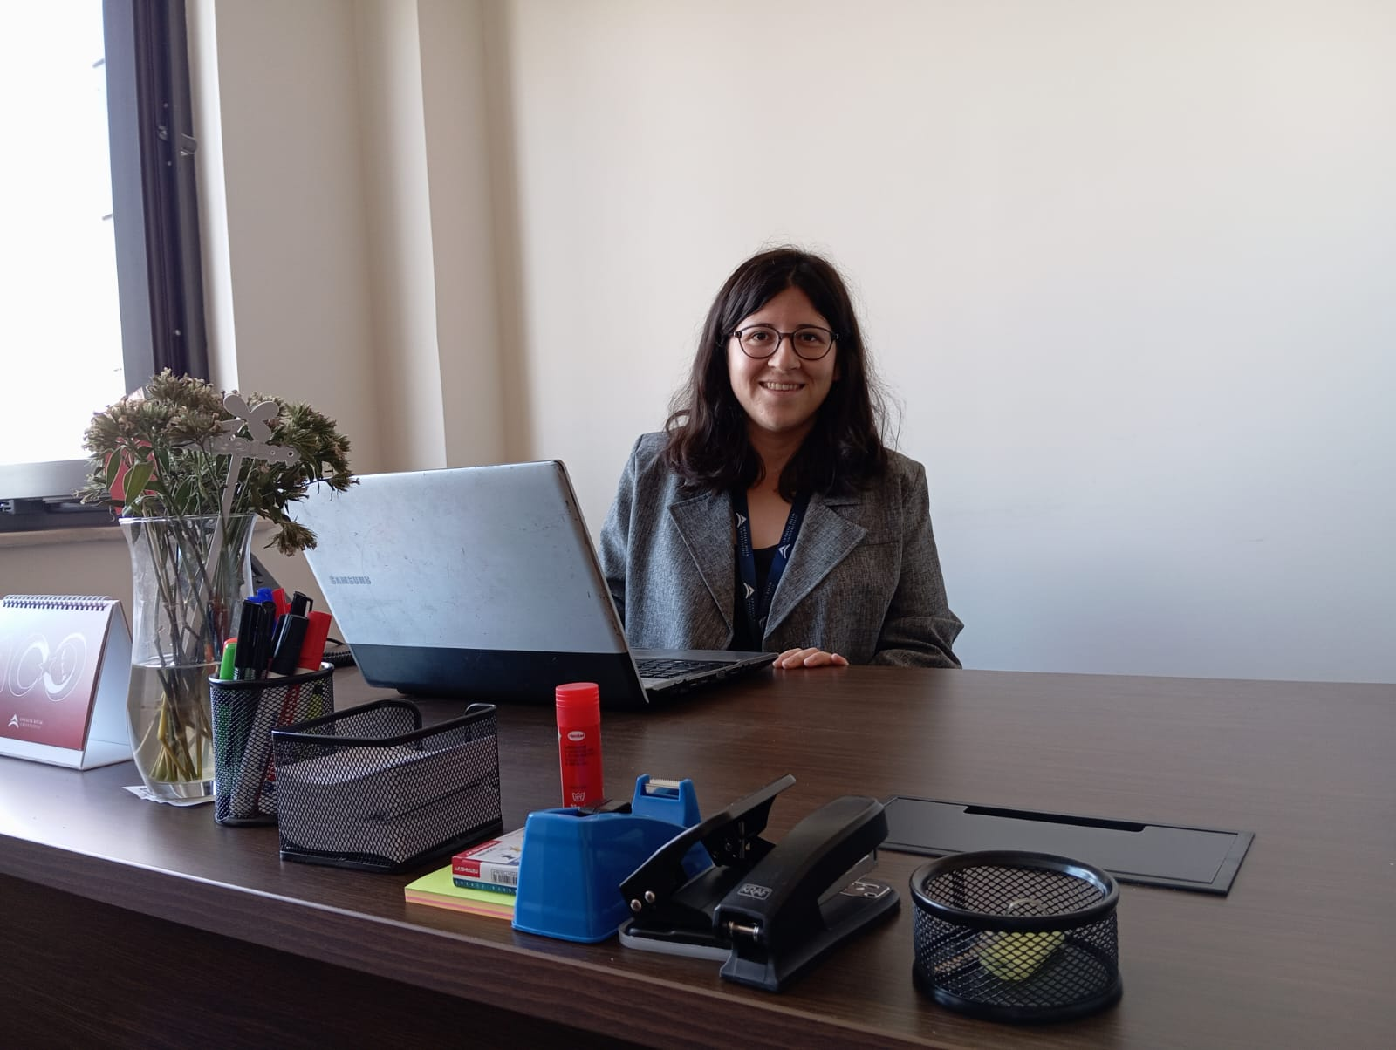
Research Assistant
Antalya Bilim University
Tourism Faculty

muge.cevik@antalya.edu.tr
+90 242 245 00 00

Müge Çevik

Education

Master
- Kocaeli University, Institute of Social Sciences, Gastronomy and Culinary Arts, 2022 - Present
Bachelor
- Dokuz Eylül University, College of Tourism, Gastronomy and Culinary Arts, 2021, GPA: 3.02/4

Academic Employment

Research Assistant | College of Tourism | Antalya Bilim University | 2023 - Present

Professional Employment

Salesman | Gıda Anonim Market | January 2023- March 2023
Commis de Cuisine  Languages  Turkish Native  English Fluent | Altın Yunus Hotel & Spa – Çeşme | July 2021 – July 2021

