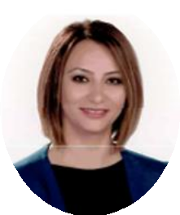
Lecturer Antalya Bilim University Vocational High School
nihal.ustunkaya@antalya.edu.tr
242 245 02 24
Nihal Üstünkaya, (MBA Candidate)

Education

Bachelor Karadeniz Technical University / School of Business and Social Sciences / Economy / 1999
Bachelor Anadolu University / Sociology / 2020

Bachelor Anadolu University / Cooking / 2023

Master Antalya Bilim University / Business Administration / 2023

Academic Employment

Lecturer – Vocational High School – Culinary -Antalya Bilim University – 2018 Continue

Professional Employment

1998-1999 Çözüm Açık Öğretim Dershanesi – Trainee Teacher
1999-2003 Türkiye İş Bankası – Private Customer Representative 2003-2018 Antalya Pastalya Pastacılık Ltd. Şti – Pastry Chef

Courses/Teaching

Basic Pastry Course
- Food and Beverage Management
- Food and Beverage Cost Control
- Entrepreneurship and Business Management
- Social and Personal Development Practices
- Desserts and Pastries in Turkish Cuisine
- Internship I
- Internship II

