**CURRICULUM VITAE** 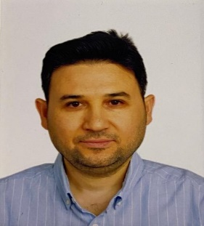

**Şenol Sarı**

**Education**

|  |  |  |  |
| --- | --- | --- | --- |
| **DEGREES** | **INSTITUTION** | **DATE** | **MAJOR FIELD** |
| PhD. | Pamukkale University | 2025-Ongoing | English Language Teaching |
| M.A. | Yeditepe University | 2024 | English Language Teaching |
| B.A. | Selçuk University | 2007 | English Language Teaching |

**Academic experience**

September 2024 – to date Lecturer of English, School of Foreign Languages, Antalya Bilim University, Antalya

July 2019 – July 2024 English Teacher, Antalya Bilim College

August 2018 – June 2020 Lecturer of English, School of Foreign Languages, Antalya Bilim University, Antalya

September 2009 – August 2018 English Language Instructor, Turkish Air Force Command

September 2007 – August 2009 English Teacher, Mimar Sinan İzzet Baysal Anatolian Vocational High School

**Certifications**

* Delta Module 1: Understanding Language, Methodology, and Resources for Teaching English
* ICAO (International Civil Aviation Organization) Course for Aviation English Rater

**Service activities**

* Organized and supervised Scrabble tournaments to enhance vocabulary and strategic thinking skills.
* Led and coordinated English Debate Club activities at various levels within the Air Force Academy and other educational institutions.
* Participated in and mentored Model United Nations (MUN) conferences organized by universities to develop students’ diplomacy and public speaking skills.
* Contributed to and supported projects funded by TÜBİTAK (The Scientific and Technological Research Council of Turkey), promoting scientific inquiry and student research.

**Conferences presented at**

* Enhancing Authorial Presence and Reader Engagement in Academic Writing, the 9th International Symposium of Limitless Education and Research (2025)
* From Neutrality to Transparency: Navigating Subjectivity in the Discussion Sections of Research Articles, 13th Annual International Conference on Humanities & Arts in a Global World, 3-6 January 2026, Athens, Greece (accepted for presentation)

**Conferences attended**

* 9th International Symposium of Limitless Education and Research (2025)
* Antalya Bilim University 6th ELT Conference
* Antalya Bilim University 8th ELT Conference
* Antalya Bilim University 9th ELT Conference
* Turkish Air Force Language School ELT Conference (2016-2018)
* Turkish Military Academy ELT Conference (2018)
* Turkish Air Force Academy ELT Conference (2017)
* Kuleli ELT Conference (2014)
* Işıklar Air Force High School ELT Conference (2009-2016)

**Conference Proceedings**

* Deveci, T., and Sarı, Ş. (2025). Enhancing authorial presence and reader engagement in academic writing. In *the Proceedings of the 9th International Symposium of Limitless Education and Research Conference* (p. 51). SEAD.

**Review Activities**

* Language editor for Journal of Limitless Education and Research (J-LER)