Tansel Tercan, PhD
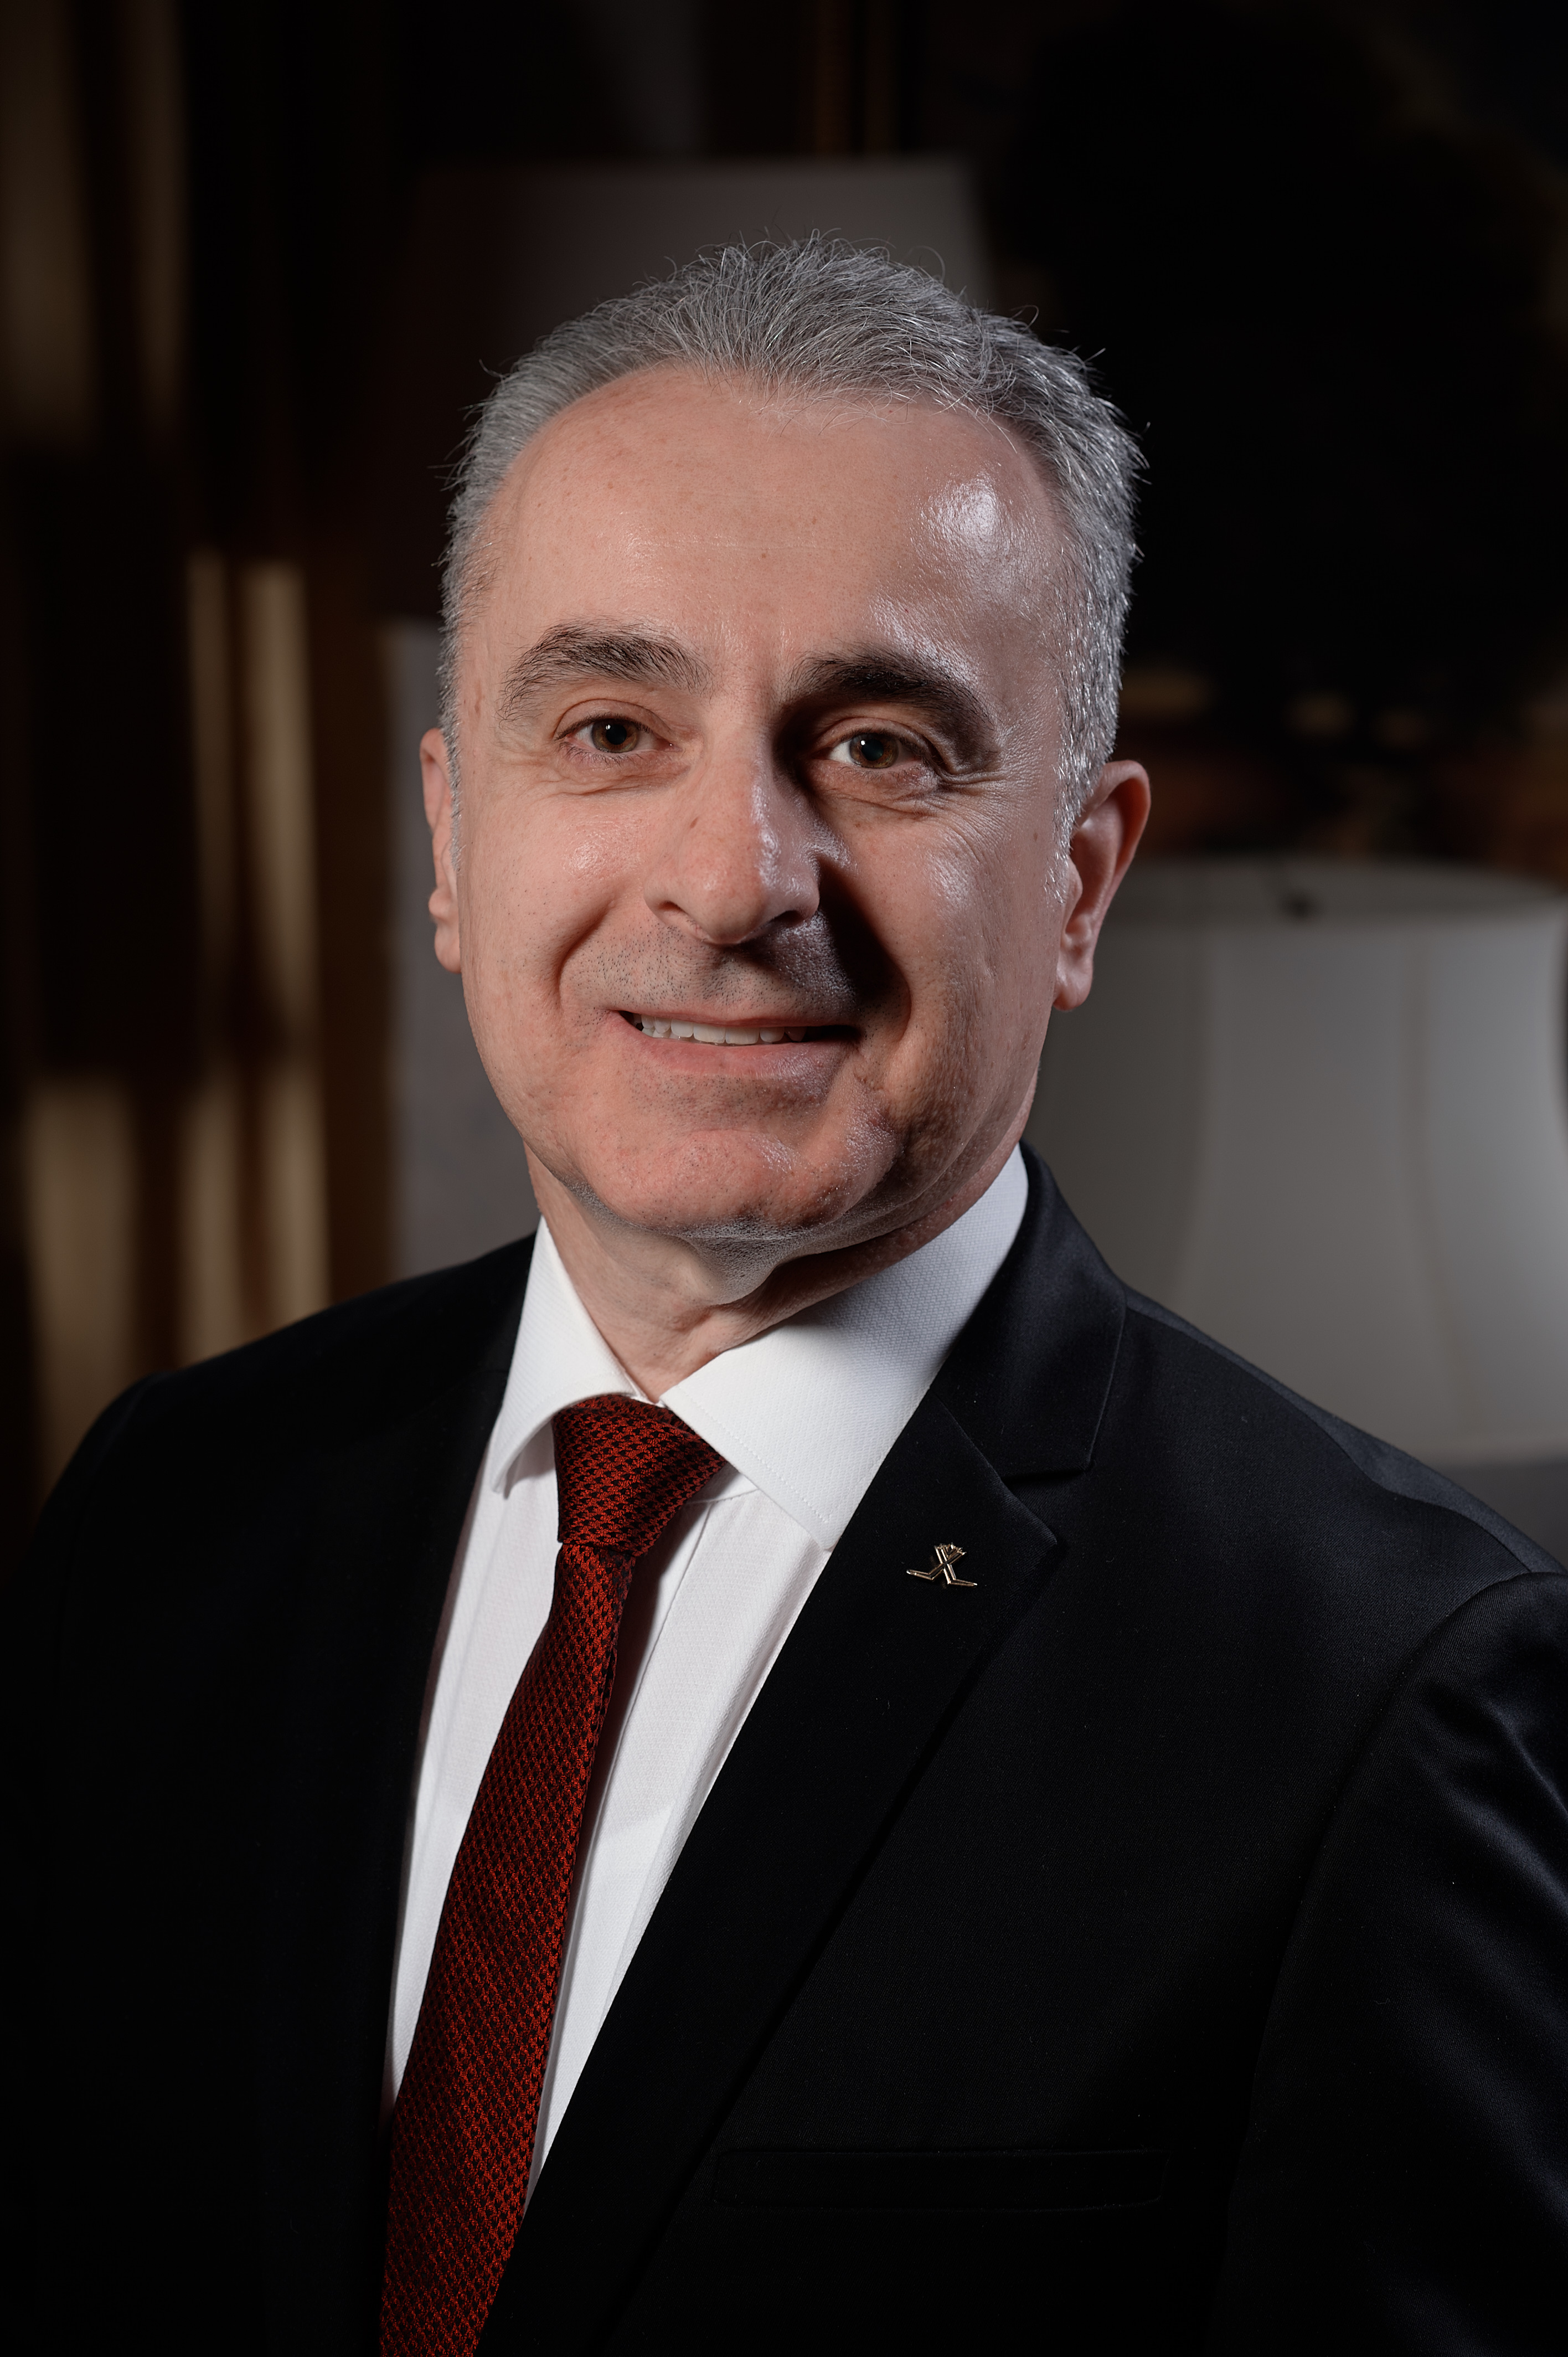PHOTO
PhD, Lecturer
Rector Adviser
Antalya Bilim University
Tourism Faculty

tansel.tercan@antalya.edu.tr
Office no
www.nursoultan.com

Education

- Bachelor Anadolu University, Faculty of Business Administration/1993/
- Master Mediterranean University, Master of Tourism & Hotel Management/2018/ 3,97
- Doctorate L.N. Gumilyov Eurasian National University/ Tourism Faculty/2021/ 3,81
- Professor in Managerial Sales and marketing strategies/ "Bachelor's Degree in Business Administration in Entrepreneurship"/ UNITED CAMPUS OF MALTA/ 2019

Academic Employment

- PhD, Lecturer / Antalya Bilim University / Tourism Faculty / Tourism / 2023

Professional Employment

- General Manger / Rixos Hotel’s & Rixos President Astana / 2003
- Antalya Bilim University / Rector Adviser / 2021

Publications

Books
- WASTE MANAGEMENT IN HOSPITALITY (Book) Detay Publishing, Certificate No: 46573 Ankara 2022

Academic Articles
- Waste management in the tourism industry: a systematic review // Reports of the National Academy of Sciences of the Republic of Kazakhstan. – 2019. – №3(325). – Р. 244-252.
- Bibliometric analysis of waste management and Recycling in tourism science from past to today // Bulletin of Pavlodar State University named after S.M. Toraigyrov. – 2020. – №3. – Р. 220-236. (Humanitarian Series).
- Analysing waste management and recycling practices for the hotel industry (Scopus) // Journal of Environmental Management and Tourism. – 2021. – №12(2). – Р. 382-381.
- Analysing waste management and recycling practices for the hotel industry (Scopus) // Journal of Environmental Management and Tourism. – 2021. – №12 (2). – Р. 382-381.
- Conference paper 1: Sustainability of tourism businesses: Rixos Sungate example // Proceedings of 7th SCF International Conference on “the Future of the European Union and Turkey-European Union Relations.” – Usak, 2019. – Р. 747-756 (April 11-13).
- Conference paper 2: The usage potential of industry 4.0 technologies in waste management in hotel enterprises. Ұлы жібек жолы – Бейбітшілік келісім және тұрақтылық жолы: I халықаралық конференциясының материалдары, түркістан. – 2019. – Б. 73-80.
- Conference paper 3: A proposal for smart restaurant business development // Proceedings of the International Online-Conference «Modern Trends of Hotel and Restaurant Business Development» – 2020. – Р. 3-6 (12 March).
- Development of Tourism Services through Sacred Sites in Kazakhstan (Scopus) / VOL. 20 NO. S6 (2023) / P. 657-669 / ISSN: 1741-8984 | e-ISSN: 1741-8992 | The abbreviated title of Migration Letters journal is: Migrat. Lett. | Migration Letters is abstracted and indexed widely, including by SCOPUS and Web of Science./ PUBLISHED: 2023-09-02
- Re-thinking the Epistemology of Paradigm in Hospitality and Tourism (Scopus) / VOL. 20 NO. S6 (2023) / P. 670-678 / ISSN: 1741-8984 | e-ISSN: 1741-8992 | The abbreviated title of Migration Letters journal is: Migrat. Lett. | Migration Letters is abstracted and indexed widely, including by SCOPUS and Web of Science./ PUBLISHED: 2023-09-02
- Biophilic Approach in the Hospitality Industry (Scopus) / VOL. 20 NO. S6 (2023) / P. 689-694 / / ISSN: 1741-8984 | e-ISSN: 1741-8992 | The abbreviated title of Migration Letters journal is: Migrat. Lett. | Migration Letters is abstracted and indexed widely, including by SCOPUS and Web of Science./ PUBLISHED: 2023-09-02
- The Establishment of Sustainable Development Aid/Financing System under Belt and Road Initiative (Scopus) / VOL. 20 NO. S6 (2023) / P. 277-290 / / ISSN: 1741-8984 | e-ISSN: 1741-8992 | The abbreviated title of Migration Letters journal is: Migrat. Lett. | Migration Letters is abstracted and indexed widely, including by SCOPUS and Web of Science./ PUBLISHED: 2023-09-02

Book Chapters
- ………..

Proceedings
- ………..

Research in Progress
- ………..
Projects

- …..

Courses/Teaching
- TRM 483 (Online), Leadership and Modern Management

Memberships
- The Member of the Directors Board Established International University of Tourism and Hospitality in Turkestan / Kazakhstan /2019
- The Member of the Directors Board of L.N. Gumilyov Eurasian National University in Astana / Kazakhstan /2022

Research Interests
- Driving – Motorsports - Reading
Languages
- English (Good command of English, reading, writing, and understanding)

